# UNIT-I

**DIODE AND APPLICATIONS**

## PN JUNCTION DIODE:

In a piece of sc, if one half is doped by p type impurity and the other half is doped by n type impurity, a PN junction is formed. The plane dividing the two halves or zones is called PN junction. As shown in the fig the n type material has high concentration of free electrons, while p type material has high concentration of holes. Therefore at the junction there is a tendency of free electrons to diffuse over to the P side and the holes to the N side. This process is called diffusion. As the free electrons move across the junction from N type to P type, the donor atoms become positively charged. Hence a positive charge is built on the N-side of the junction. The free electrons that cross the junction uncover the negative acceptor ions by filing the holes. Therefore a negative charge is developed on the p –side of the junction..This net negative charge on the p side prevents further diffusion of electrons into the p side. Similarly the net positive charge on the N side repels the hole crossing from p side to N side. Thus a barrier sis set up near the junction which prevents the further movement of charge carriers i.e. electrons and holes. As a consequence of induced electric field across the depletion layer, an electrostatic potential difference is established between P and N regions, which are called the potential barrier, junction barrier, diffusion potential or contact potential, Vo. The magnitude of the contact potential Vo varies with doping levels and temperature. Vo is 0.3V for Ge and 0.72 V for Si.

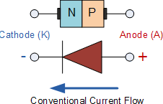

Fig 1.6: Symbol of PN Junction Diode

The electrostatic field across the junction caused by the positively charged N-Type region tends to drive the holes away from the junction and negatively charged p type regions tend to drive the electrons away from the junction. The majority holes diffusing out of the P region leave behind negatively charged acceptor atoms bound to the lattice, thus exposing a negatives pace charge in a previously neutral region. Similarly electrons diffusing from the N region expose positively ionized donor atoms and a double space charge builds up at the junction as shown in the fig. 1.7a

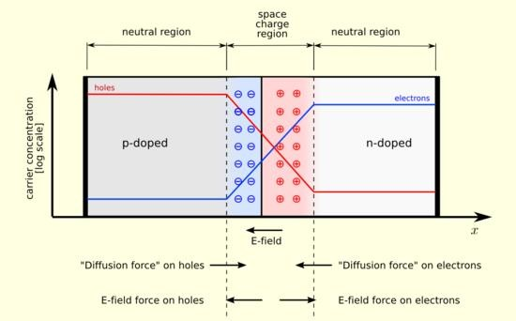

Fig 1.7a

It is noticed that the space charge layers are of opposite sign to the majority carriers diffusing into them, which tends to reduce the diffusion rate. Thus the double space of the layer causes an electric field to be set up across the junction directed from N to P regions, which is in such a direction to inhibit the diffusion of majority electrons and holes as illustrated in fig 1.7b. The shape of the charge density, ρ, depends upon how diode id doped. Thus the junction region is depleted of mobile charge carriers. Hence it is called depletion layer, space region, and transition region. The depletion region is of the order of 0.5µm thick. There are no mobile carriers in this narrow depletion region. Hence no current flows across the junction and the system is in equilibrium. To the left of this depletion layer, the carrier concentration is p= NA and to its right it is n= ND.

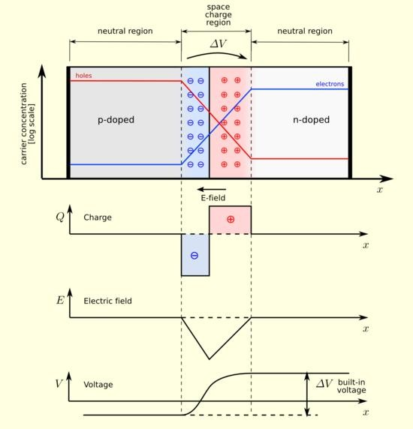

Fig 1.7b

#### FORWARD BIASED JUNCTION DIODE

When a diode is connected in a **Forward Bias** condition, a negative voltage is applied to the N- type material and a positive voltage is applied to the P-type material. If this external voltage becomes greater than the value of the potential barrier, approx. 0.7 volts for silicon and 0.3 volts for germanium, the potential barriers opposition will be overcome and current will start to flow. This is because the negative voltage pushes or repels electrons towards the junction giving them the energy to cross over and combine with the holes being pushed in the opposite direction towards the junction by the positive voltage. This results in a characteristics curve of zero current flowing up to this voltage point,

called the "knee" on the static curves and then a high current flow through the diode with little increase in the external voltage as shown below.

**Forward Characteristics Curve for a Junction Diode**

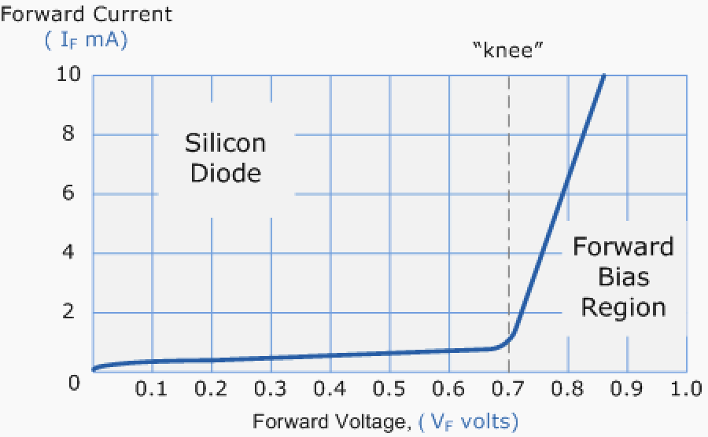

Fig 1.8a: Diode Forward Characteristics

The application of a forward biasing voltage on the junction diode results in the depletion layer becoming very thin and narrow which represents a low impedance path through the junction thereby allowing high currents to flow. The point at which this sudden increase in current takes place is represented on the static I-V characteristics curve above as the "knee" point.

**Forward Biased Junction Diode showing a Reduction in the Depletion Layer**

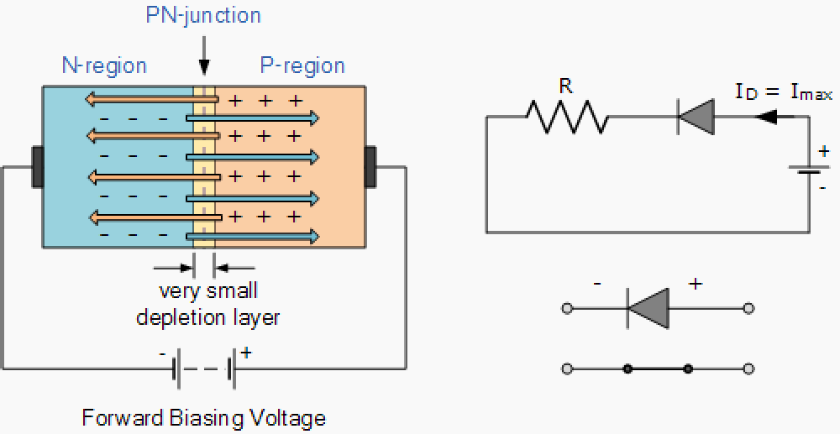

Fig 1.8b: Diode Forward Bias

This condition represents the low resistance path through the PN junction allowing very large currents to flow through the diode with only a small increase in bias voltage. The actual potential difference across the junction or diode is kept constant by the action of the depletion layer at approximately 0.3v for germanium and approximately 0.7v for silicon junction diodes. Since the diode can conduct "infinite" current above this knee point as it effectively becomes a short circuit, therefore resistors are used in series with the diode to limit its current flow. Exceeding its maximum forward current specification causes the device to dissipate more power in the form of heat than it was designed for resulting in a very quick failure of the device.

#### 1.1.2 PN JUNCTION UNDER REVERSE BIAS CONDITION: Reverse Biased Junction Diode

When a diode is connected in a **Reverse Bias** condition, a positive voltage is applied to the N-type

material and a negative voltage is applied to the P-type material. The positive voltage applied to the N- type material attracts electrons towards the positive electrode and away from the junction, while the holes in the P-type end are also attracted away from the junction towards the negative electrode. The net result is that the depletion layer grows wider due to a lack of electrons and holes and presents a high impedance path, almost an insulator. The result is that a high potential barrier is created thus preventing current from flowing through the semiconductor material.

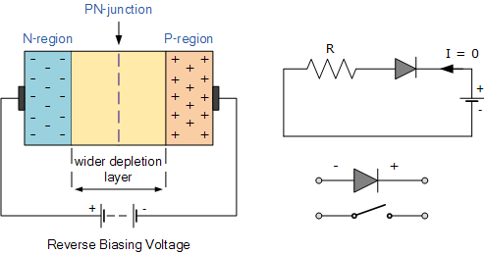

**Reverse Biased Junction Diode showing an Increase in the Depletion**

Fig 1.9a: Diode Reverse Bias

This condition represents a high resistance value to the PN junction and practically zero current flows through the junction diode with an increase in bias voltage. However, a very small **leakage current** does flow through the junction which can be measured in microamperes, (μA). One final point, if the reverse bias voltage Vr applied to the diode is increased to a sufficiently high enough value, it will

cause the PN junction to overheat and fail due to the avalanche effect around the junction. This may cause the diode to become shorted and will result in the flow of maximum circuit current, and this shown as a step downward slope in the reverse static characteristics curve below.

**Reverse Characteristics Curve for a Junction Diode**

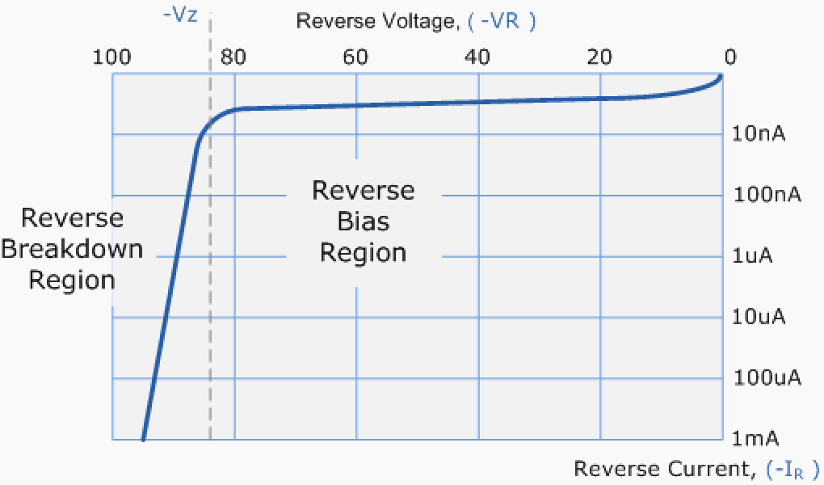

Fig 1.9b: Diode Reverse Characteristics

Sometimes this avalanche effect has practical applications in voltage stabilizing circuits where a series limiting resistor is used with the diode to limit this reverse breakdown current to a preset maximum value thereby producing a fixed voltage output across the diode. These types of diodes are commonly known as [**Zener Diodes**](http://www.electronics-tutorials.ws/diode/diode_7.html)

## VI CHARACTERISTICS AND THEIR TEMPERATURE DEPENDENCE

Diode terminal characteristics equation for diode junction current:

Where VT = KT/q;

VD_ diode terminal voltage, Volts

Io _ temperature-dependent saturation current, µA T _ absolute temperature of p-n junction, K

K _ Boltzmann’s constant 1.38x 10 -23J/K) q _ electron charge 1.6x10-19 C

** = empirical constant, 1 for Ge and 2 for Si

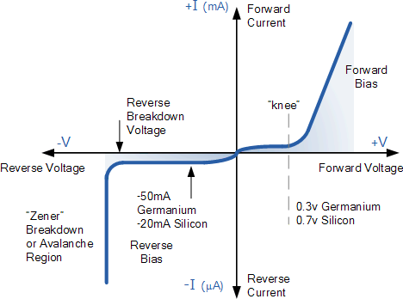

Fig 1.10: Diode Characteristics

#### Temperature Effects on Diode

Temperature can have a marked effect on the characteristics of a silicon semiconductor diode as shown in Fig. 11 It has been found experimentally that the reverse saturation current Io will just about double in magnitude for every 10°C increase in temperature.

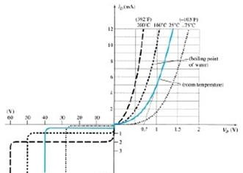

Fig 1.11 Variation in Diode Characteristics with temperature change

It is not uncommon for a germanium diode with an Io in the order of 1 or 2 A at 25°C to have a leakage current of 100 A - 0.1 mA at a temperature of 100°C. Typical values of Io for silicon are much lower than that of germanium for similar power and current levels. The result is that even at high temperatures the levels of Io for silicon diodes do not reach the same high levels obtained. For germanium—a very important reason that silicon devices enjoy a significantly higher level of development and utilization in design. Fundamentally, the open-circuit equivalent in the reverse bias region is better realized at any temperature with silicon than with germanium. The increasing levels of Io with temperature account for the lower levels of threshold voltage, as shown in Fig. 1.11. Simply increase the level of Io in and not rise in diode current. Of course, the level of TK also will be increase, but the increasing level of Io will overpower the smaller percent change in TK. As the temperature increases the forward characteristics are actually becoming more “ideal,”

## IDEAL VERSUS PRACTICAL RESISTANCE LEVELS

#### DC or Static Resistance

The application of a dc voltage to a circuit containing a semiconductor diode will result in an operating point on the characteristic curve that will not change with time. The resistance of the diode at the operating point can be found simply by finding the corresponding levels of VD and ID as shown in Fig. 1.12 and applying the following Equation:

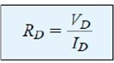

The dc resistance levels at the knee and below will be greater than the resistance levels obtained for the vertical rise section of the characteristics. The resistance levels in the reverse-bias region will naturally be quite high. Since ohmmeters typically employ a relatively constant-current source, the resistance determined will be at a preset current level (typically, a few mill amperes).

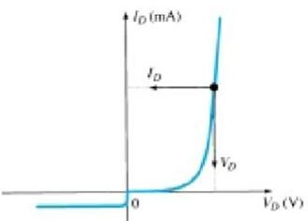

Fig 1.12 Determining the dc resistance of a diode at a particular operating point.

#### AC or Dynamic Resistance

It is obvious from Eq. 1.3 that the dc resistance of a diode is independent of the shape of the characteristic in the region surrounding the point of interest. If a sinusoidal rather than dc input is applied, the situation will change completely. The varying input will move the instantaneous operating point up and down a region of the characteristics and thus defines a specific change in current and voltage as shown in Fig. 1.13. With no applied varying signal, the point of operation would be the Q- point appearing on Fig. 1.13 determined by the applied dc levels. The designation Q-point is derived from the word quiescent, which means “still or unvarying.” A straight-line drawn tangent to the curve through the Q-point as shown in Fig. 1.13 will define a particular change in voltage and current that can be used to determine the ac or dynamic resistance for this region of the diode characteristics. In equation form,



Where Δ Signifies a finite change in the quantity

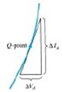

Fig 1.13: Determining the ac resistance of a diode at a particular operating point.

## DIODE EQUIVALENT CIRCUITS

An equivalent circuit is a combination of elements properly chosen to best represent the actual terminal characteristics of a device, system, or such in a particular operating region. In other words, once the equivalent circuit is defined, the device symbol can be removed from a schematic and the equivalent circuit inserted in its place without severely affecting the actual behavior of the system. The result is often a network that can be solved using traditional circuit analysis techniques.

#### Piecewise-Linear Equivalent Circuit

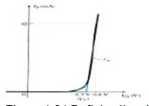One technique for obtaining an equivalent circuit for a diode is to approximate the characteristics of the device by straight-line segments, as shown in Fig. 1.31. The resulting equivalent circuit is naturally called the piecewise-linear equivalent circuit. It should be obvious from Fig. 1.31 that the straight-line segments do not result in an exact duplication of the actual characteristics, especially in the knee region. However, the resulting segments are sufficiently close to the actual curve to establish an equivalent circuit that will provide an excellent first approximation to the actual behaviour of the device. The ideal diode is included to establish that there is only one direction of conduction through the device, and a reverse-bias condition will result in the open- circuit state for the device. Since a silicon semiconductor, diode does not reach the conduction state until VD reaches 0.7 V with a forward bias (as shown in Fig. 1.14a), a battery VT opposing the conduction direction must appear in the equivalent circuit as shown in Fig. 1.14b. The battery simply specifies that the voltage across the device must be greater than the threshold battery voltage before conduction through the device in the direction dictated by the ideal diode can be established. When conduction is established, the resistance of the diode will be the specified value of rav.

Fig: 1.14aDiode piecewise-linear model characteristics

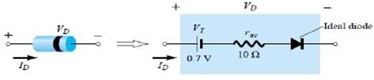

Fig: 1.14b Diode piecewise-linear model equivalent circuit

The approximate level of rav can usually be determined from a specified operating point on the specification sheet. For instance, for a silicon semiconductor diode, if IF _ 10 mA (a forward conduction current for the diode) at VD _ 0.8 V, we know for silicon that a shift of 0.7 V is required before the characteristics rise.

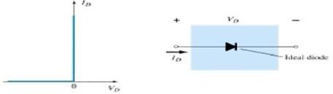

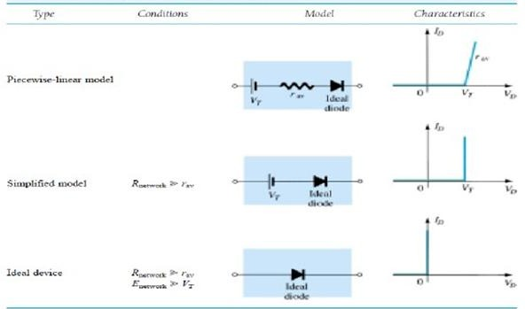Fig 1.15 Ideal Diode and its characteristics

Fig 1.16: Diode equivalent circuits(models)

## TRANSITION AND DIFFUSION CAPACITANCE

Electronic devices are inherently sensitive to very high frequencies. Most shunt capacitive effects that can be ignored at lower frequencies because the reactance XC=1/2πfC is very large (open- circuit equivalent). This, however, cannot be ignored at very high frequencies. XC will become sufficiently small due to the high value of f to introduce a low-reactance “shorting” path. In the p-n semiconductor diode, there are two capacitive effects to be considered. In the reverse-bias region we have the transition- or depletion region capacitance (CT), while in the forward-bias region we have the diffusion (CD) or storage capacitance. Recall that the basic equation for the capacitance of a parallel- plate capacitor is defined by C=€A/d, where € is the permittivity of the dielectric (insulator) between the plates of area A separated by a distance d. In the reverse-, bias region there is a depletion region (free of carriers) that behaves essentially like an insulator between the layers of opposite charge. Since the depletion width (d) will increase with increased reverse-bias potential, the resulting transition capacitance will decrease. The fact that the capacitance is dependent on the applied reverse-bias potential has application in a number of electronic systems. Although the effect described above will also be present in the forward-bias region, it is over shadowed by a capacitance effect directly dependent on the rate at which charge is injected into the regions just outside the depletion region. The capacitive effects described above are represented by a capacitor in parallel with the ideal diode, as shown in Fig. 1.38. For low- or mid-frequency applications (except in the power area), however, the capacitor is normally not included in the diode symbol.



Fig 1.17: Including the effect of the transition or diffusion capacitance on the semiconductor diode

**Diode capacitances:** The diode exhibits two types of capacitances transition capacitance and diffusion capacitance.

* Transition capacitance: The capacitance which appears between positive ion layer in n-region and negative ion layer in p-region.
* Diffusion capacitance: This capacitance originates due to diffusion of charge carriers in the opposite regions.

The transition capacitance is very small as compared to the diffusion capacitance. In reverse bias transition, the capacitance is the dominant and is given by:



where CT - transition capacitance A - diode cross sectional area

W - depletion region width

In forward bias, the diffusion capacitance is the dominant and is given by:



where CD - diffusion capacitance

dQ - change in charge stored in depletion region V - change in applied voltage

- time interval for change in voltage g - diode conductance

r - diode resistance

The diffusion capacitance at low frequencies is given by the formula:



The diffusion capacitance at high frequencies is inversely proportional to the frequency and is given by the formula:

*Note: The variation of diffusion capacitance with applied voltage is used in the design of varactor.*

## BREAK DOWN MECHANISMS

When an ordinary **P-N junction diode** is reverse biased, normally only very small reverse saturation current flows. This current is due to movement of minority carriers. It is almost independent of the voltage applied. However, if the reverse bias is increased, a point is reached when the junction breaks down and the reverse current increases abruptly. This current could be large enough to destroy the junction. If the reverse current is limited by means of a suitable series resistor, the power dissipation at the junction will not be excessive, and the device may be operated continuously in its

breakdown region to its normal (reverse saturation) level. It is found that for a suitably designed diode, the breakdown voltage is very stable over a wide range of reverse currents. This quality gives the breakdown diode many useful applications as a voltage reference source.

The critical value of the voltage, at which the breakdown of a P-N junction diode occurs, is called the *breakdown voltage.* The breakdown voltage depends on the width of the depletion region, which, in turn, depends on the doping level. The junction offers almost zero resistance at the breakdown point.

There are two mechanisms by which breakdown can occur at a reverse biased P-N junction:

##### avalanche breakdown and

1. ***Zener breakdown.***

**Avalanche breakdown**

The minority carriers, under reverse biased conditions, flowing through the junction acquire a kinetic energy which increases with the increase in reverse voltage. At a sufficiently high reverse voltage (say 5 V or more), the kinetic energy of minority carriers becomes so large that they knock out electrons from the covalent bonds of the semiconductor material. As a result of collision, the liberated electrons in turn liberate more electrons and the current becomes very large leading to the breakdown of the crystal structure itself. This phenomenon is called the avalanche breakdown*.* The breakdown region is the knee of the characteristic curve. Now the current is not controlled by the junction voltage but rather by the external circuit.

**Zener breakdown**

Under a very high reverse voltage, the depletion region expands and the potential barrier increases leading to a very high electric field across the junction. The electric field will break some of the covalent bonds of the semiconductor atoms leading to a large number of free minority carriers, which suddenly increase the reverse current. This is called the Zener effect. The breakdown occurs at a particular and constant value of reverse voltage called the breakdown voltage, it is found that Zener breakdown occurs at electric field intensity of about 3 x 107 V/m.

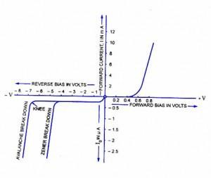

Fig 1.18: Diode characteristics with breakdown

Either of the two (Zener breakdown or avalanche breakdown) may occur independently, or both of these may occur simultaneously. Diode junctions that breakdown below 5 V are caused by Zener effect. Junctions that experience breakdown above 5 V are caused by avalanche effect. Junctions that breakdown around 5 V are usually caused by combination of two effects. The Zener breakdown occurs in heavily doped junctions (P-type semiconductor moderately doped and N-type heavily doped), which produce narrow depletion layers. The avalanche breakdown occurs in lightly doped junctions, which produce wide depletion layers. With the increase in junction temperature Zener breakdown voltage is reduced while the avalanche breakdown voltage increases. The Zener diodes have a negative temperature coefficient while avalanche diodes have a positive temperature coefficient. Diodes that have breakdown voltages around 5 V have zero temperature coefficient. The breakdown phenomenon is reversible and harmless so long as the safe operating temperature is maintained.

## ZENER DIODES

The **Zener diode** is like a general-purpose signal diode consisting of a silicon PN junction. When biased in the forward direction it behaves just like a normal signal diode passing the rated current, but as soon as a reverse voltage applied across the zener diode exceeds the rated voltage of the device, the diodes breakdown voltage VB is reached at which point a process called *Avalanche Breakdown* occurs in the semiconductor depletion layer and a current starts to flow through the diode to limit this increase in voltage.

The current now flowing through the zener diode increases dramatically to the maximum circuit value (which is usually limited by a series resistor) and once achieved this reverse saturation current remains fairly constant over a wide range of applied voltages. This breakdown voltage point, VB is called the "zener voltage" for zener diodes and can range from less than one volt to hundreds of volts.

The point at which the zener voltage triggers the current to flow through the diode can be very accurately controlled (to less than 1% tolerance) in the doping stage of the diodes semiconductor construction giving the diode a specific *zener breakdown voltage*, (Vz) for example, 4.3V or 7.5V. This zener breakdown voltage on the I-V curve is almost a vertical straight line.

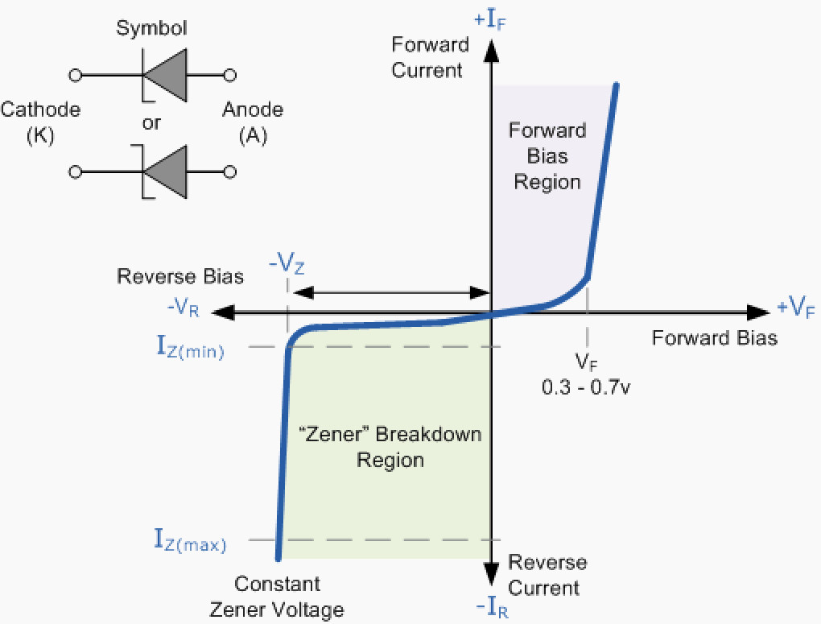**Zener Diode I-V Characteristics**

Fig 1.19 : Zener diode characteristics

The **Zener Diode** is used in its "reverse bias" or reverse breakdown mode, i.e. the diodes anode connects to the negative supply. From the I-V characteristics curve above, we can see that the zener diode has a region in its reverse bias characteristics of almost a constant negative voltage regardless of the value of the current flowing through the diode and remains nearly constant even with large changes in current as long as the zener diodes current remains between the breakdown current IZ(min) and the maximum current rating IZ(max).

This ability to control itself can be used to great effect to regulate or stabilize a voltage source against supply or load variations. The fact that the voltage across the diode in the breakdown region is almost constant turns out to be an important application of the zener diode as a voltage regulator. The function of a regulator is to provide a constant output voltage to a load connected in parallel with it in spite of the ripples in the supply voltage or the variation in the load current and the zener diode will

continue to regulate the voltage until the diodes current falls below the minimum IZ(min) value in the reverse breakdown region.

# SPECIAL PURPOSE ELECTRONIC DEVICES

## PRINCIPLE OF OPERATION AND CHARACTERISTICS OF TUNNEL DIODE

A **tunnel diode** or **Esaki diode** is a type of semiconductor diode which is capable of very fast operation, well into the microwave frequency region, by using quantum mechanical effects.

It was invented in August 1957 by Leo Esaki when he was with Tokyo Tsushin Kogyo, now known as Sony. In 1973 he received the Nobel Prize in Physics, jointly with Brian Josephson, for discovering the electron tunneling effect used in these diodes. Robert Noyce independently came up with the idea of a tunnel diode while working for William Shockley, but was discouraged from pursuing it.

http://upload.wikimedia.org/wikipedia/commons/thumb/c/c4/Tunnel_diode_symbol.svg/250px-Tunnel_diode_symbol.svg.png

Fig 1.19: Tunnel diode schematic symbol

These diodes have a heavily doped p–n junction only some 10 nm (100 Å) wide. The heavy doping results in a broken bandgap, where conduction band electron states on the n-side are more or less aligned with valence band hole states on the p-side. Tunnel diodes were manufactured by Sony for the first time in 1957 followed by General Electric and other companies from about 1960, and are still made in low volume today. Tunnel diodes are usually made from germanium, but can also be made in gallium arsenide and silicon materials. They can be used as oscillators, amplifiers, frequency converters and detectors.Tunnelling Phenomenon:

In a conventional semiconductor diode, conduction takes place while the p–n junction is forward biased and blocks current flow when the junction is reverse biased. This occurs up to a point known as the “reverse breakdown voltage” when conduction begins (often accompanied by destruction of the device). In the tunnel diode, the dopant concentration in the p and n layers are increased to the point where the **reverse breakdown voltage** becomes **zero** and the diode conducts in the reverse direction. However, when forward-biased, an odd effect occurs called “quantum mechanical tunnelling” which gives rise to a region where an *increase* in forward voltage is accompanied by a *decrease* in forward current. This negative resistance region can be exploited in a solid state version of the dynatron oscillator which normally uses a [tetrode](http://en.wikipedia.org/wiki/Tetrode) thermionic valve (or tube).

#### Forward bias operation

Under normal forward bias operation, as voltage begins to increase, electrons at first tunnel through the very narrow p–n junction barrier because filled electron states in the conduction band on the n-

side become aligned with empty valence band hole states on the p-side of the p-n junction. As voltage increases further these states become more misaligned and the current drops – this is called *negative resistance* because current decreases with increasing voltage. As voltage increases yet further, the diode begins to operate as a normal diode, where electrons travel by conduction across the p–n junction, and no longer by tunneling through the p–n junction barrier. Thus the most important operating region for a tunnel diode is the negative resistance region.

#### Reverse bias operation

When used in the reverse direction they are called **back diodes** and can act as fast rectifiers with zero offset voltage and extreme linearity for power signals (they have an accurate square law characteristic in the reverse direction).

Under reverse bias filled states on the p-side become increasingly aligned with empty states on the n- side and electrons now tunnel through the pn junction barrier in reverse direction – this is the Zener effect that also occurs in zener diodes.

#### Technical comparisons

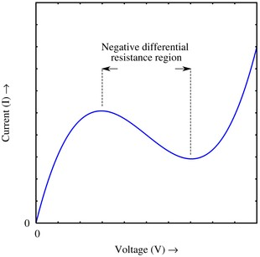

Fig 1.20a: current-voltage characteristic of tunnel diode

A rough approximation of the VI curve for a tunnel diode, showing the negative differential resistance region. The Japanese physicist Leo Esaki invented the tunnel diode in 1958.It consists of a p-n junction with highly doped regions. Because of the thinness of the junction, the electrons can pass through the potential barrier of the dam layer at a suitable polarization, reaching the energy states on the other sides of the junction. The current-voltage characteristic of the diode is represented in Figure 1.20a. In this sketch *i p* and *Up* are the peak, and *iv* and *Uv* are the valley values for the current and voltage

respectively. The form of this dependence can be qualitatively explained by considering the tunneling processes that take place in a thin p-n junction.

#### Energy band structure of tunnel diode:

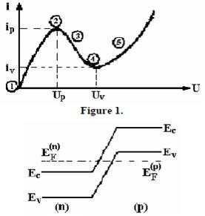

Fig 1.20b Energy band structure of tunnel diode

For the degenerated semiconductors, the energy band diagram at thermal equilibrium is presented in Figure 1.20b.

In Figure 1.20c the tunneling processes in different points of the current voltage characteristic for the tunnel diode are presented.

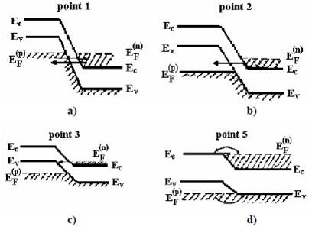

#### Advantages of tunnel diodes:

* Environmental immunity i.e. peak point is not a function of temperature.
* Low cost.
* Low noise.
* Low power consumption.
* High speed i.e. tunneling takes place very fast at the speed of light in the order of nanoseconds
* Simplicity i.e. a tunnel diode can be used along with a d.c supply and a few passive elements to obtain various application circuits.

#### Applications for tunnel diodes:

* + local oscillators for UHF television tuners
  + Trigger circuits in oscilloscopes
  + High speed counter circuits and very fast-rise time pulse generator circuits
  + The tunnel diode can also be used as low-noise microwave amplifier.

## PHOTO DIODE

The photo diode is a semiconductor p-n junction device whose region of operation is limited to the reverse biased region.The figure below shows the symbol of photodiode

http://upload.wikimedia.org/wikipedia/commons/thumb/2/2b/Photodiode_symbol.svg/220px-Photodiode_symbol.svg.png

Fig 1.26:Symbol of photodiode.

#### Principle of operation:

A photodiode is a type [of photo detector](http://en.wikipedia.org/wiki/Photodetector) capable of converting [light](http://en.wikipedia.org/wiki/Light) into either [current](http://en.wikipedia.org/wiki/Electric_current) or [voltage](http://en.wikipedia.org/wiki/Voltage), depending upon the mode of operation. The common, traditional [solar cell](http://en.wikipedia.org/wiki/Solar_cell) used to generate electric [solar power](http://en.wikipedia.org/wiki/Solar_power) is a large area photodiode. A photodiode is designed to operate in reverse bias. The deletion region width is large. Under normal conditions it carries small reverse current due to minority charge carriers. When light is incident through glass window on the p-n junction, photons in the light bombard the p-n junction and some energy s imparted to the valence electrons. So valence electrons

break covalent bonds and become free electrons. Thus more electron-hole pairs are generated. Thus total number of minority charge carriers increases and hence reverse current increases.This is the basic principle of operation of photo diode.

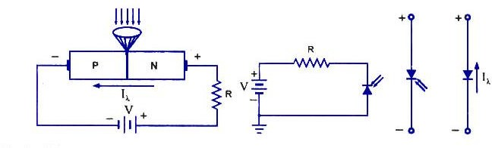

Fig 1.27: Basic Biasing Arrangement and construction of photodiode and symbols

#### Characteristics of photodiode:

When the P-N junction is reverse-biased, a reverse saturation current flows due to thermally generated holes and electrons being swept across the junction as the minority carriers. With the increase in temperature of the junction more and more hole-electron pairs are created and so the reverse saturation current I0 increases. The same effect can be had by illuminating the junction. When light en- ergy bombards a P-N junction, it dislodges valence electrons. The more light striking the junction the larger the reverse current in a diode. It is due to generation of more and more charge carriers with the increase in level of illumination. This is clearly shown in *‘* figure for different intensity levels. The dark current is the current that exists when no light is incident. It is to be noted here that current becomes zero only with a positive applied bias equals to VQ. The almost equal spacing between the curves for the same increment in luminous flux reveals that the reverse saturation current I0 increases linearly with the luminous flux as shown in figure. Increase in reverse voltage does not increase the reverse current significantly, because all available charge carriers are already being swept across the junction. For reducing the reverse saturation current I0 to zero, it is necessary to forward bias the junction by an amount equal to barrier potential. Thus the photodiode can be used as a photoconductive device.

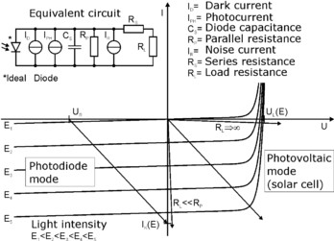

Fig 1.28: characteristics of photodiode

On removal of reverse bias applied across the photodiode, minority charge carriers continue to be swept across the junction while the diode is illuminated. This has the effect of increasing the concentration of holes in the P-side and that of electrons in the N-side But the barrier potential is negative on the P-side and positive on the N-side, and was created by holes flowing from P to N-side and electrons from N to P-side during fabrication of junction. Thus the flow of minority carriers tends to reduce the barrier potential.

When an external circuit is connected across the diode terminals, the minority carrier; return to the original side via the external circuit. The electrons which crossed the junction from P to N-side now flow out through the N-terminal and into the P-terminal This means that the device is behaving as a voltage cell with the N-side being the negative terminal and the P-side the positive terminal. Thus, the photodiode is & photovoltaic device as well as photoconductive device.

#### Advantages:

The advantages of photodiode are:

1.It can be used as variable resistance device. 2.Highly sensitive to the light.

3.The speed of operation is very high.

#### Disadvantages:

1.Temperature dependent dark current. 2.poor temperature stability.

3.Current needs amplification for driving other circuits.

#### Applications:

1.Alarm system. 2.counting system.

# LED:

They are the most visible type of diode, that emit a fairly narrow bandwidth of either visible light at different coloured wavelengths, invisible infra-red light for remote controls or laser type light when a forward current is passed through them.

The “**Light Emitting Diode**” or LED as it is more commonly called, is basically just a specialised type of diode as they have very similar electrical characteristics to a PN junction diode. This means that an LED will pass current in its forward direction but block the flow of current in the reverse direction.

Light emitting diodes are made from a very thin layer of fairly heavily doped semiconductor material and depending on the semiconductor material used and the amount of doping, when forward biased an LED will emit a coloured light at a particular spectral wavelength.

When the diode is forward biased, electrons from the semiconductors conduction band recombine with holes from the valence band releasing sufficient energy to produce photons which emit a monochromatic (single colour) of light. Because of this thin layer a reasonable number of these photons can leave the junction and radiate away producing a coloured light output.

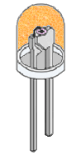

**LED Construction**

Then we can say that when operated in a forward biased direction **Light Emitting Diodes** are semiconductor devices that convert electrical energy into light energy.

The construction of a Light Emitting Diode is very different from that of a normal signal diode. The PN junction of an LED is surrounded by a transparent, hard plastic epoxy resin hemispherical shaped shell or body which protects the LED from both vibration and shock.

Surprisingly, an LED junction does not actually emit that much light so the epoxy resin body is constructed in such a way that the photons of light emitted by the junction are reflected away from the surrounding substrate base to which the diode is attached and are focused upwards through the domed top of the LED, which itself acts like a lens concentrating the amount of light. This is why the emitted light appears to be brightest at the top of the LED.

However, not all LEDs are made with a hemispherical shaped dome for their epoxy shell. Some indication LEDs have a rectangular or cylindrical shaped construction that has a flat surface on top or their body is shaped into a bar or arrow. Generally, all LED’s are manufactured with two legs protruding from the bottom of the body.

Also, nearly all modern light emitting diodes have their cathode, ( – ) terminal identified by either a notch or flat spot on the body or by the cathode lead being shorter than the other as the anode ( + ) lead is longer than the cathode (k).

Unlike normal incandescent lamps and bulbs which generate large amounts of heat when illuminated, the light emitting diode produces a “cold” generation of light which leads to high efficiencies than the normal “light bulb” because most of the generated energy radiates away within the visible spectrum. Because LEDs are solid-state devices, they can be extremely small and durable and provide much longer lamp life than normal light sources.

## Light Emitting Diode Colours

So how does a light emitting diode get its colour. Unlike normal signal diodes which are made for detection or power rectification, and which are made from either Germanium or Silicon semiconductor materials, **Light Emitting Diodes** are made from exotic semiconductor compounds such as Gallium Arsenide (GaAs), Gallium Phosphide (GaP), Gallium Arsenide Phosphide (GaAsP), Silicon Carbide (SiC) or Gallium Indium Nitride (GaInN) all mixed together at different ratios to produce a distinct wavelength of colour.

Different LED compounds emit light in specific regions of the visible light spectrum and therefore produce different intensity levels. The exact choice of the semiconductor material used will determine the overall wavelength of the photon light emissions and therefore the resulting colour of the light emitted.

### Light Emitting Diode Colours

|  |  |  |  |
| --- | --- | --- | --- |
| Typical LED Characteristics | | | |
| Semiconductor Material | Wavelength | Colour | VF @ 20mA |
| GaAs | 850-940nm | Infra-Red | 1.2v |
| GaAsP | 630-660nm | Red | 1.8v |
| GaAsP | 605-620nm | Amber | 2.0v |
| GaAsP:N | 585-595nm | Yellow | 2.2v |
| AlGaP | 550-570nm | Green | 3.5v |
| SiC | 430-505nm | Blue | 3.6v |
| GaInN | 450nm | White | 4.0v |

Thus, the actual colour of a light emitting diode is determined by the wavelength of the light emitted, which in turn is determined by the actual semiconductor compound used in forming the PN junction during manufacture.

Therefore the colour of the light emitted by an LED is NOT determined by the colouring of the LED’s plastic body although these are slightly coloured to both enhance the light output and to indicate its colour when its not being illuminated by an electrical supply.

Light emitting diodes are available in a wide range of colours with the most common being RED, AMBER,  YELLOW  and GREEN and are thus widely used as visual indicators and as moving light displays.

Recently developed blue and white coloured LEDs are also available but these tend to be much more expensive than the normal standard colours due to the production costs of mixing together two or more complementary colours at an exact ratio within the semiconductor compound and also by injecting nitrogen atoms into the crystal structure during the doping process.

From the table above we can see that the main P-type dopant used in the manufacture of **Light Emitting Diodes** is Gallium (Ga, atomic number 31) and that the main N-type dopant used is Arsenic (As, atomic number 33) giving the resulting compound of Gallium Arsenide (GaAs) crystalline structure.

The problem with using Gallium Arsenide on its own as the semiconductor compound is that it radiates large amounts of low brightness infra-red radiation (850nm-940nm approx.) from its junction when a forward current is flowing through it.

The amount of infra-red light it produces is okay for television remote controls but not very useful if we want to use the LED as an indicating light. But by adding Phosphorus (P, atomic number 15), as a third dopant the overall wavelength of the emitted radiation is reduced to below 680nm giving visible red light to the human eye. Further refinements in the doping process of the PN junction have resulted in a range of colours spanning the spectrum of visible light as we have seen above as well as infra-red and ultra-violet wavelengths.

By mixing together a variety of semiconductor, metal and gas compounds the following list of LEDs can be produced.

### Types of Light Emitting Diode

* Gallium Arsenide (GaAs) – infra-red
* Gallium Arsenide Phosphide (GaAsP) – red to infra-red, orange
* Aluminium Gallium Arsenide Phosphide (AlGaAsP) – high-brightness red, orange-red, orange, and yellow
* Gallium Phosphide (GaP) – red, yellow and green
* Aluminium Gallium Phosphide (AlGaP) – green
* Gallium Nitride (GaN) – green, emerald green
* Gallium Indium Nitride (GaInN) – near ultraviolet, bluish-green and blue
* Silicon Carbide (SiC) – blue as a substrate
* Zinc Selenide (ZnSe) – blue
* Aluminium Gallium Nitride (AlGaN) – ultraviolet

Like conventional PN junction diodes, light emitting diodes are current-dependent devices with its forward voltage drop VF, depending on the semiconductor compound (its light colour) and on the forward biased LED current. Most common LED’s require a forward operating voltage of between approximately 1.2 to 3.6 volts with a forward current rating of about 10 to 30 mA, with 12 to 20 mA being the most common range.

Both the forward operating voltage and forward current vary depending on the semiconductor material used but the point where conduction begins and light is produced is about 1.2V for a standard red LED to about 3.6V for a blue LED.

The exact voltage drop will of course depend on the manufacturer because of the different dopant materials and wavelengths used. The voltage drop across the LED at a particular current value, for example 20mA, will also depend on the initial conduction VF point. As an LED is effectively a diode, its forward current to voltage characteristics curves can be plotted for each diode colour as shown below.

### Light Emitting Diodes I-V Characteristics.

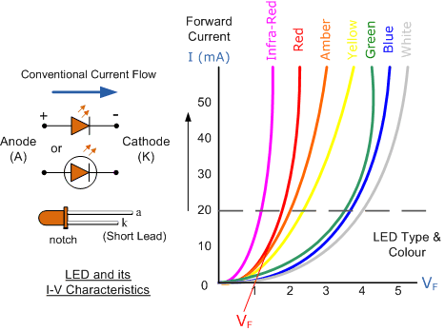

Light Emitting Diode (LED) Schematic symbol and I-V Characteristics Curves  
showing the different colours available.

Before a light emitting diode can “emit” any form of light it needs a current to flow through it, as it is a current dependant device with their light output intensity being directly proportional to the forward current flowing through the LED.

As the LED is to be connected in a forward bias condition across a power supply it should be current limited using a series resistor to protect it from excessive current flow. Never connect an LED directly to a battery or power supply as it will be destroyed almost instantly because too much current will pass through and burn it out.

From the table above we can see that each LED has its own forward voltage drop across the PN junction and this parameter which is determined by the semiconductor material used, is the forward voltage drop for a specified amount of forward conduction current, typically for a forward current of 20mA.

In most cases LEDs are operated from a low voltage DC supply, with a series resistor, RS used to limit the forward current to a safe value from say 5mA for a simple LED indicator to 30mA or more where a high brightness light output is needed.

# RECTIFIERS & FILTERS

## INTRODUCTION

For the operation of most of the electronics devices and circuits, a d.c. source is required. So it is advantageous to convert domestic a.c. supply into d.c.voltages. The process of converting a.c. voltage into d.c. voltage is called as rectification. This is achieved with i) Step-down Transformer, ii) Rectifier,

1. Filter and iv) Voltage regulator circuits.

These elements constitute d.c. regulated power supply shown in the fig 1 below.

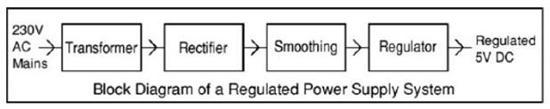

Fig 2.1: Block Diagram of regulated D.C Power Supply

* + Transformer – steps down 230V AC mains to low voltage AC.
  + Rectifier – converts AC to DC, but the DC output is varying.
  + Smoothing – smooth the DC from varying greatly to a small ripple.
  + Regulator – eliminates ripple by setting DC output to a fixed voltage.

The block diagram of a regulated D.C. power supply consists of step-down transformer, rectifier, filter, voltage regulator and load. An ideal regulated power supply is an electronics circuit designed to provide a predetermined d.c. voltage Vo which is independent of the load current and variations in the input voltage ad temperature. If the output of a regulator circuit is a AC voltage then it is termed as voltage stabilizer, whereas if the output is a DC voltage then it is termed as voltage regulator.

#### RECTIFIER

Any electrical device which offers a low resistance to the current in one direction but a high resistance to the current in the opposite direction is called rectifier. Such a device is capable of converting a sinusoidal input waveform, whose average value is zero, into a unidirectional Waveform, with a non- zero average component. A rectifier is a device, which converts a.c. voltage (bi-directional) to pulsating

d.c. voltage (Unidirectional).

#### Characteristics of a Rectifier Circuit:

Any electrical device which offers a low resistance to the current in one direction but a high resistance to the current in the opposite direction is called rectifier. Such a device is capable of converting a sinusoidal input waveform, whose average value is zero, into a unidirectional waveform, with a non- zero average component.

A rectifier is a device, which converts a.c. voltage (bi-directional) to pulsating d.c..Load currents: They are two types of output current. They are average or d.c. current and RMS currents.

Average or DC current: The average current of a periodic function is defined as the area of one cycle of the curve divided by the base.

It is expressed mathematically as

* 1. Average value/dc value/mean value=

*Area over one period Total time period*

*Vdc*  *T* *Vd* (*wt*)

1 *T*

0

* 1. Effective (or) R.M.S current:

The effective (or) R.M.S. current squared ofa periodic function of time is given by the area of one cycle of the curve, which represents the square of the function divided by the base.

*Vrms* 

*T* *V d* (*wt*)

1 *T*

2

0

* 1. Peak factor:

It is the ratio of peak value to Rms value

*peakvalue*

Peak factor **=**

*rmsvalue*

* 1. Form factor:

It is the ratio of Rms value to average value

It is the ratio of d.c output power to the a.c. input power. It signifies, how efficiently the rectifier circuit converts a.c. power into d.c. power.

**  *o* / *p power*

*i* / *p power*

* 1. Peak Inverse Voltage (PIV):

It is defined as the maximum reverse voltage that a diode can withstand without destroying the junction.

* 1. Transformer Utilization Factor (UTF):

The d.c. power to be delivered to the load in a rectifier circuit decides the rating of the Transformer used in the circuit. So, transformer utilization factor is defined as

*TUF* 

*Pdc*

*pac*(*rated*)

* 1. % Regulation:

The variation of the d.c. output voltage as a function of d.c. load current is called regulation. The percentage regulation is defined as

% Re *gulation*  *VNL*  *VFL* *100

*VFL*

For an ideal power supply, % Regulation is zero.

## CLASSIFICATION OF RECTIFIERS

Using one or more diodes in the circuit, following rectifier circuits can be designed.

1. Half - Wave Rectifier
2. Full – Wave Rectifier
3. Bridge Rectifier

#### HALF-WAVE RECTIFIER:

A Half – wave rectifier as shown in **fig 1.2** is one, which converts a.c. voltage into a pulsating voltage using only one half cycle of the applied a.c. voltage.

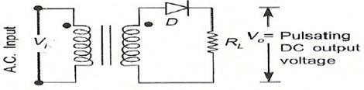

Fig 1.2: Basic structure of Half-Wave Rectifier

The a.c. voltage is applied to the rectifier circuit using step-down transformer-rectifying element i.e., p- n junction diode and the source of a.c. voltage, all connected is series. The a.c. voltage is applied to the rectifier circuit using step-down transformer

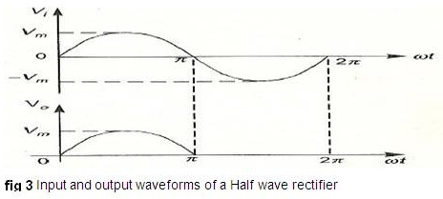

V=Vm sin (wt)

The input to the rectifier circuit, Where Vm is the peak value of secondary a.c. voltage.

#### Operation:

For the positive half-cycle of input a.c. voltage, the diode D is forward biased and hence it conducts. Now a current flows in the circuit and there is a voltage drop across RL. The waveform of the diode current (or) load current is shown in **fig 3**.

For the negative half-cycle of input, the diode D is reverse biased and hence it does not

Conduct. Now no current flows in the circuit i.e., i=0 and Vo=0. Thus for the negative half- cycle no power is delivered to the load.

**Analysis:**

In the analysis of a HWR, the following parameters are to be analyzed.

* + - 1. DC output current
      2. DC Output voltage
      3. R.M.S. Current
      4. R.M.S. voltage
      5. Rectifier Efficiency (η )
      6. Ripple factor (γ )
      7. Peak Factor
      8. % Regulation
      9. Transformer Utilization Factor (TUF)
      10. form factor
      11. o/p frequency

Let a sinusoidal voltage Vi be applied to the input of the rectifier.

Then V=Vm sin (wt) Where Vm is the maximum value of the secondary voltage. Let the diode be idealized to piece-wise linear approximation with resistance Rf in the forward direction i.e., in the ON state and Rr (=∞) in the reverse direction i.e., in the OFF state. Now the current ‘i’ in the diode (or) in the load resistance RL is given by V=Vm sin (wt)

#### DISADVANTAGES OF HALF-WAVE RECTIFIER:

1. The ripple factor is high.
2. The efficiency is low.
3. The Transformer Utilization factor is low.

Because of all these disadvantages, the half-wave rectifier circuit is normally not used as a power rectifier circuit.

#### FULL WAVE RECTIFIER:

A full-wave rectifier converts an ac voltage into a pulsating dc voltage using both half cycles of the applied ac voltage. In order to rectify both the half cycles of ac input, two diodes are used in this circuit. The diodes feed a common load RL with the help of a center-tap transformer. A center-tap transformer is the one, which produces two sinusoidal waveforms of same magnitude and frequency but out of phase with respect to the ground in the secondary winding of the transformer. The full wave rectifier is shown in the **fig 4** below

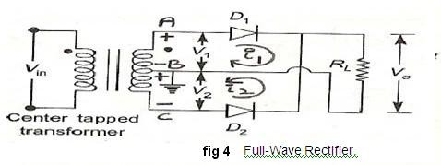

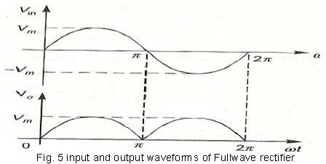

Fig. 5 shows the input and output wave forms of the ckt.

During positive half of the input signal, anode of diode D1 becomes positive and at the same time the anode of diode D2 becomes negative. Hence D1 conducts and D2 does not

conduct. The load current flows through D1 and the voltage drop across RL will be equal to the input voltage.

During the negative half cycle of the input, the anode of D1 becomes negative and the anode of D2 becomes positive. Hence, D1 does not conduct and D2 conducts. The load current flows through D2 and the voltage drop across RL will be equal to the input voltage. It is noted that the load current flows in the both the half cycles of ac voltage and in the same direction through the load resistance.

#### Advantages

* 1. Ripple factor = 0.482 (against 1.21 for HWR)
  2. Rectification efficiency is 0.812 (against 0.405 for HWR)
  3. Better TUF (secondary) is 0.574 (0.287 for HWR)
  4. No core saturation problem Disadvantages:
     1. Requires center tapped transformer.

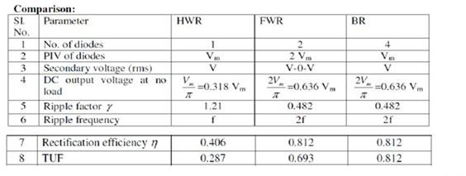

#### FILTERS

The output of a rectifier contains dc component as well as ac component. Filters are used to minimize the undesirable ac i.e., ripple leaving only the dc component to appear at the output.

Some important filters are:

1. Inductor filter
2. Capacitor filter
3. LC or L section filter
4. CLC or Π-type filter

#### CAPACITOR FILTER

This is the most simple form of the [**filter circuit**](http://www.circuitstoday.com/filter-circuits)and in this arrangement a high value capacitor C is placed directly across the output terminals, as shown in figure. During the conduction period it gets charged and stores up energy to it during non-conduction period. Through this process, the time duration during which Ft is to be noted here that the capacitor C gets charged to the peak because there is no resistance (except the negligible forward resistance of diode) in the charging path. But the discharging time is quite large (roughly 100 times more than the charging time depending upon the value of RL) because it discharges through load resistance RL.

The function of the capacitor filter may be viewed in terms of impedances. The large value capacitor C offers a low impedance shunt path to the ac components or ripples but offers high impedance to the dc component. Thus ripples get bypassed through capacitor C and only dc component flows through the load resistance RL

##### Capacitor filter is very popular because of its low cost, small size, light weight and good characteristics.



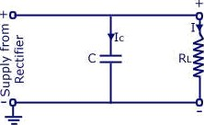VL

Ci rcuit Diagram

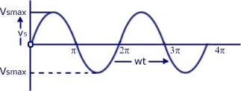

Input voltage Waveform to Rectifier

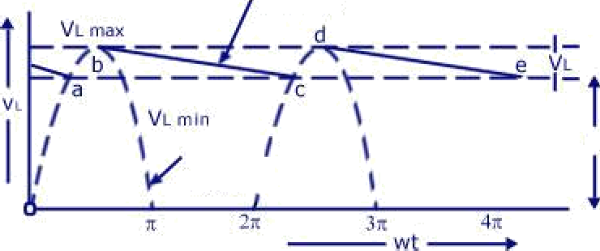

Ve or VL

Vdc

Rectified and filtered Output Voltage Waveform

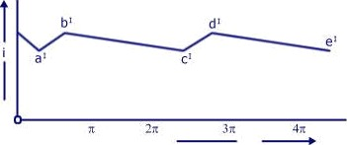

Load Current Waveform

Half-wave Rectkier With Shunt Capacitor Filter

CircuiNToday.oom

CAPACITOR FILTER WITH HWR

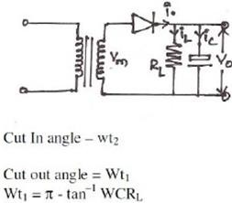

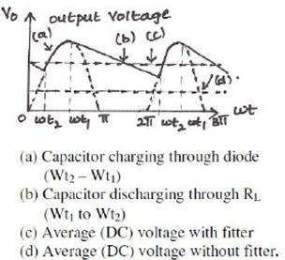

CAPACITOR FILTER WITH FWR

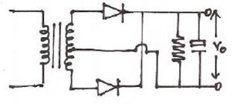

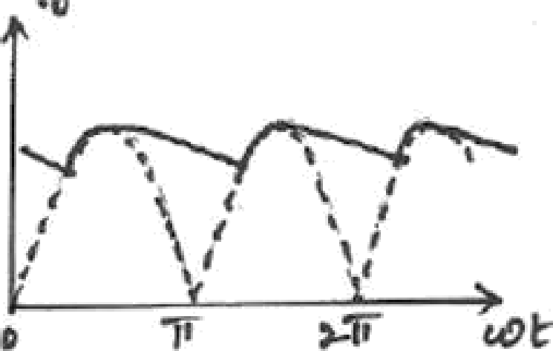

Rippte factor

Ripple Freq m R = ? ripple ’treq ,i>q.

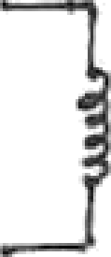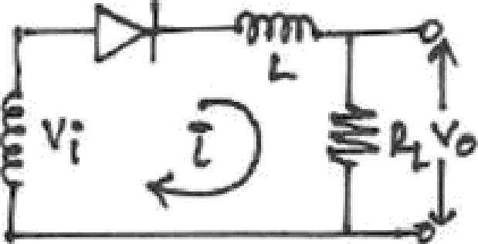

ct

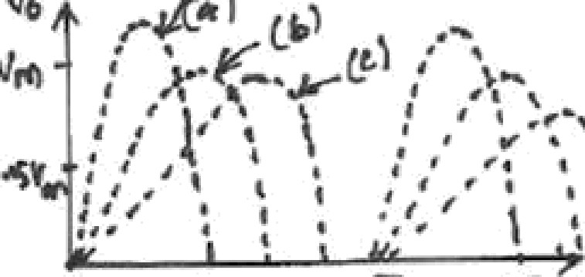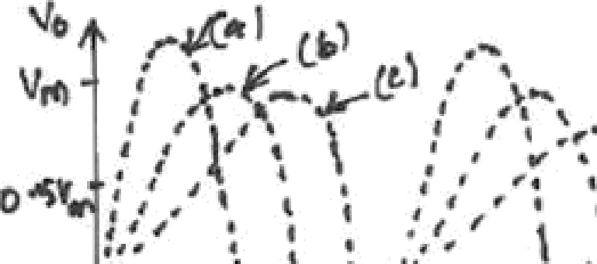

#### The worth noting points about shunt capacitor filter are:

1. For a fixed-value filter capacitance larger the load resistance RL larger will be the discharge time constant CRL and therefore, lower the ripples and more the output voltage. On the other hand lower the load resistance (or more the load current), lower will be the output voltage.
2. Similarly smaller the filter capacitor, the less charge it can hold and more it will discharge. Thus the peak-to-peak value of the ripple will increase, and the average dc level will decrease. Larger the filter capacitor, the more charge it can hold and the less it will discharge. Hence the peak-to-peak value of the ripple will be less, and the average dc level will increase. But, the maximum value of the capacitance that can be employed is limited by another factor. The larger the capacitance value, the greater is the current required to charge the capacitor to a given voltage. The maximum current that can be handled by a diode is limited by the figure quoted by the manufacturer. Thus the maximum value of the capacitance, that can be used in the shunt filter capacitor is limited.